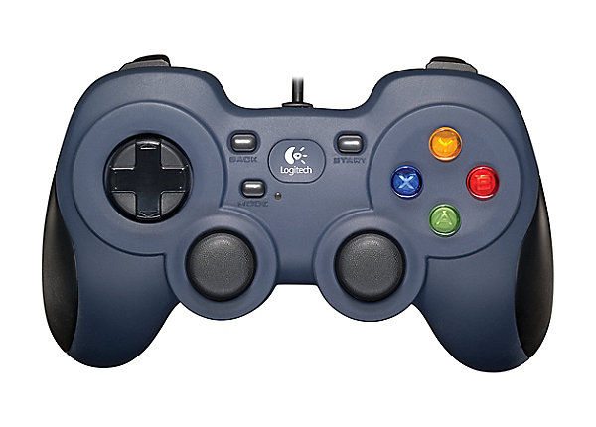

Controller

L2 trigger- Open grabber

L Bump – Grabber rotation (horizontal)

90-degree snap

R2 trigger – Close grabber

R bump – Grabber Rotation (vertical)

Fine driving

Lift down

Turning

0 degree snap

270-degree snap

180-degree snap

Life up

Linear slide in

Linear slide out

Driver



L trigger - Snap left 90 degrees

R trigger – snap right 90 degrees

Driving

Block flipper

Turning

Block flipper

u

A+B+X+Y – capstone endgame

A+B – relative control

Baseplate grabber

Baseplate grabber

Control capstone endgame

Hold B – retract linear slide